Module 2: Serving the Customer throughout the Policy Lifecycle 1
Lesson 4: Claim Administration 1
Learning Objectives 2
Claim Administration Purpose and Staff 2
The Claim Process 5
Whom to Pay, How Much, and How 12
Claim Investigations and Claim Fraud 27
Unfair Claim Practices 36
Claim Processing Efficiency 40

Module 2: Serving the Customer throughout the Policy Lifecycle
A customer's contact with an insurer most likely begins when they are thinking about purchasing a policy, and can last until the policyowner dies and the insurer pays the policy proceeds to the beneficiary. In between, the insurer underwrites and issues the policy, and meets the customer’s service needs while the policy is in force. In this module, you’ll learn about the tasks an insurer performs at each stage of the policy lifecycle.
In this module, you’ll learn about
- How insurers engage with potential customers and distribute products to meet customer needs
- How insurers process insurance applications, evaluate the risk they represent, and determine the appropriate premium to charge
- How insurers try to optimize the experience of their customers
- How insurers balance paying legitimate claims promptly and accurately with avoiding paying illegitimate claims

Lesson 4: Claim Administration

If a policy stays in force until the death of the insured, the insurer has an obligation to pay the policy proceeds promptly and accurately. However, the insurer also has an obligation NOT to pay illegitimate claims. See how insurers balance these two obligations.

Learning Objectives

- Explain the purpose of effective claim administration, and describe the staff involved in processing claims.
- Identify the steps in the claim process, and explain how to determine whether death benefits are payable.
- Determine the correct amount and correct recipient of a death benefit, and describe how the benefit can be paid.
- Identify the factors that are likely to trigger a claim investigation, and describe different types of claim fraud and measures insurers can take to prevent them.
- Describe the Model Unfair Claims Settlement Practices Act, and give examples of unfair claim practices that would result in a violation of this act.
- Explain various ways that insurers improve and evaluate claim processing efficiency.

Claim Administration Purpose and Staff
Learning Objective
Explain the purpose of effective claim administration and describe the staff involved in processing claims.

Through claims, a company fulfills its promise to policyowners and beneficiaries—prompt payment of policy benefits when an insured event occurs.
Effective claim administration requires satisfying two somewhat contradictory objectives.
- Claims should be processed as rapidly as possible to meet the needs of beneficiaries and comply with claims processing regulations.
- Companies must ensure that they are paying only valid claims. A small number of life insurance claims are submitted under erroneous interpretations of policy provisions. An even smaller number of claims are submitted fraudulently.
Inaccurate or ineffective claims practices can cost an insurer financially and in reputation. That's why companies establish standard procedures to ensure effective claims processing. In this lesson, we discuss how a company reviews claim information and determines whether benefits are payable.
Claim Philosophy and Authority Levels
Effective claim processing begins with a claim philosophy and established claim practices that guide the claim department's operations.
Forthright's Claim Philosophy
To act promptly, fairly, and courteously in paying all eligible claims and denying all ineligible claims.

Can all claim analysts process all kinds of claims?
- Yes
- No
- It depends
Claim paying authority is tiered. A claim analyst's authority gradually increases based on his experience and training. The following is an example of how tiered authority works. Of course, the specific amounts may vary from company to company.
Amount of Claim Approval Authority
Employee | Routine Claims | Higher-Risk Claims
Analyst Trainee | $25,000 claim amount | No authority
Analyst | $200,000 claim amount | No authority
Senior Claim Analyst | $600,000 claim amount | $600,000 claim amount
Claim Supervisor | $700,000 claim amount | $700,000 claim amount
Claim Manager | $1,000,000 claim amount | $1,000,000 claim amount
Note that claim analysts are authorized to approve higher claim amounts for routine claims that are not within the contestable period than they can approve for higher risk claims. Higher risk claims involve the accidental death benefit provision, the incontestability provision, or suspicion of fraud or unusual legal complications, which usually must be handled by more senior claims staff.

True or False?

The goal of claim administration departments is to pay all claims immediately.
- True
- False
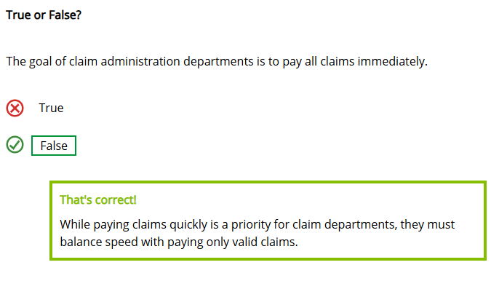

The Claim Process
Learning Objective
Identify the steps in the claim process and explain how to determine whether death benefits are payable.
The process begins when the claimant—usually the beneficiary or policyowner—notifies the insurer of a loss.
The insurer then asks the claimant to complete a claim form, or claimant's statement, that provides information about the claim and authorizes medical caregivers, government agencies, employers, and others to provide the insurer with information relevant to the claim.
The basic claim form requires that the claimant provide the date, place, cause, and circumstance of the insured's death. If the death occurred within a specified period after policy issue, typically two years, or if the death was accidental or unusual in any way, the insurer may require that the claimant complete more details on the claim form or complete a specialized questionnaire.
Once the claims department receives the claim form, it begins the claim process. We will discuss the following steps in the process.
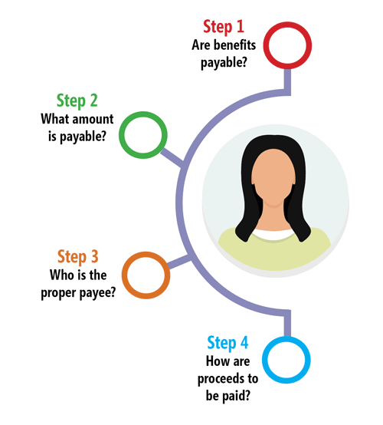
Determining if Benefits Are Payable
Here's what a claim analyst must verify to determine whether death benefits are payable:
- The policy was in force when the loss occurred.
- The deceased is the insured.
- The loss occurred.
- The policy covers the loss.
The analyst also examines whether the policy is contestable and, if so, whether the application for insurance contains any material misrepresentations.
Policy Status, Deceased's Identity, and Proof of Loss
Determining whether the policy was in force when the insured died—had premiums been paid?—and whether the deceased was the insured are typically straightforward.
Determining whether the loss occurred may be trickier. The claimant must supply proof of loss. In the United States, an official death certificate is the accepted proof of loss. But, a death certificate can't be issued if there's no body.
So what happens if the body's missing?
When an insured disappears, the claimant is unable to present proof of the insured's death. Whether or not the disappearance can be explained generally determines how the claim analyst proceeds. Click or touch each heading below to learn more.
Explainable Disappearance
The claim analyst may presume the insured to be dead if a specific peril can reasonably explain the disappearance, such as a plane crash in the ocean with no bodies found.
He probably would accept the claimant's statement and accident reports as proof of death and would continue with the claim evaluation.

Unexplainable Disappearance
If no specific peril can reasonably explain the disappearance, the claim analyst usually denies a life claim that is filed immediately after the disappearance.
An insurer cannot approve a claim until it receives sufficient proof of the insured's death.
In the United States, if the insured hasn't reappeared after a certain period (five or seven years, depending on the jurisdiction), the claimant can petition the court for an order presuming the insured's death.
A court order stating that the insured is presumed dead establishes proof of the insured's death. If the policy has been kept in force during the disappearance, the claim analyst usually will accept the court order as proof of loss and will continue the claim evaluation.

Policy Exclusions
A claim analyst next determines whether the policy covers the loss. One reason it may not is a policy exclusion, such as the suicide exclusion.
When an insured person dies during the suicide exclusion period, the claim analyst determines whether the cause of death was suicide. If the insurer can prove it was, it refunds the premiums paid, less any outstanding policy loans.
Sometimes when completing an application for insurance, the applicant gives false information or leaves out important information. If such a misrepresentation is important to the insurer's evaluation of the risk, it's called a material misrepresentation.
Most misrepresentations are minor—the applicant states that the insured broke his left arm, when actually it was the right arm. Here are some examples of material misrepresentation.
Type of Information | Example of Material Misrepresentation
Health | Failure to disclose a known medical impairment that adversely affects life expectancy
Occupation or avocation | Failure to disclose a dangerous job or hobby
Habits | Failure to disclose past abuse of alcohol or controlled substances
Number of traffic violations | Misstatements of the number or severity of moving violations or collisions
Other insurance applications denied or rated | Concealing information about insurance applications that have been denied, assigned to a high-risk class, or charged an additional premium
Normally, if an insured dies during a life insurance policy's contestable period and if the claim analyst finds out that the application contains a material misrepresentation, the insurer may rescind (void) the policy. The legal process of voiding an insurance contract because of material misrepresentation is known as rescission. The insurer refunds the premiums paid minus any policy loan outstanding. In the United States, life insurance policies typically provide a contestable period of two years. The contestable period may vary by state.
In many jurisdictions, the cause of the insured's death does not have to be related to the misrepresented information for the policy to be rescinded.

Think you can be a claim analyst? Analyze a few claims and decide which ones are payable.

November 17, 2013, Sarah Lawson, the policyowner-insured of an individual life policy, disappeared under unexplainable circumstances. Seven years later, on December 1, 2020, there was still no evidence of Ms. Lawson's reappearance, and a court issued an order presuming her death.
On December 15, 2020, the beneficiary of Ms. Lawson's policy submitted a claim for the policy proceeds. The insurer most likely will accept the court order as proof of loss and continue with the claim evaluation process, regardless of whether premiums for the policy were paid during the entire period of disappearance.
- True
- False
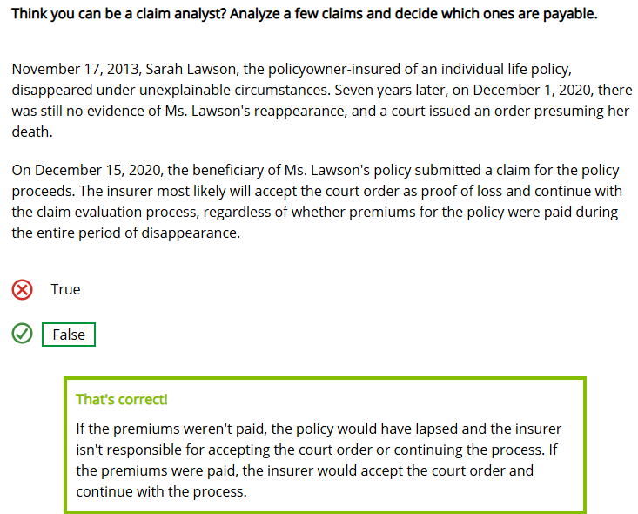

Antoine Blake purchased a whole life policy from the Barnard Insurance Company on June 12, 2017. The policy contained a typical two-year suicide exclusion period. On August 23, 2020, Mr. Blake committed suicide. At the time of his death, no policy loans were outstanding.

In this situation, the beneficiary of Mr. Blake's policy was entitled to receive
- No payment of any kind
- A refund of all premiums paid only
- The policy's net cash surrender value only
- The policy's full death benefit
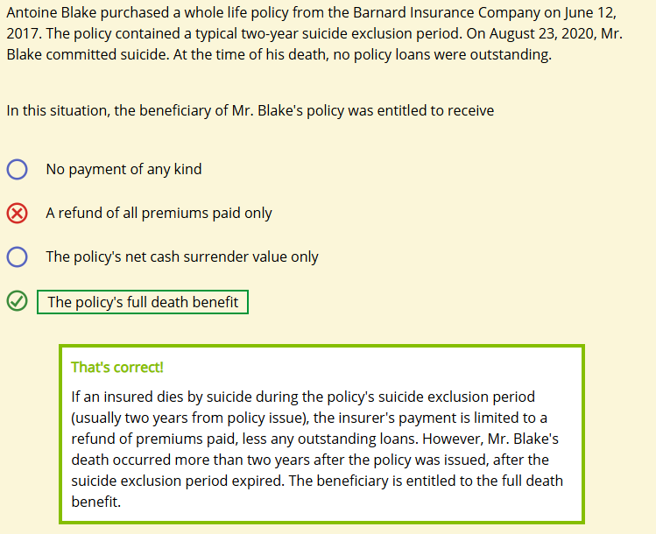
Toby Barnard was analyzing a claim submitted during the policy's contestable period. He found out that the insured had not reported that he'd had a heart attack 18 months prior to policy issue. Had this information been known, the insurer wouldn't have issued the policy. The cause of death was cancer.

Toby was most likely able to deny the claim and rescind the policy due to material misrepresentation in the application.
- True
- False
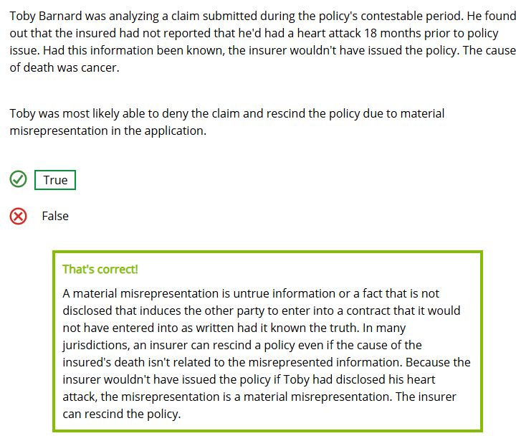

Whom to Pay, How Much, and How
Learning Objective
Determine the correct amount and correct recipient of a death benefit and describe how the benefit can be paid.
Determining the Policy Proceeds
After the claim analyst verifies a valid claim, the next step is to calculate the benefit payable. Most people think this is equal to the face amount of the policy, but that's not always true.
The face amount is the basic death benefit, but several different amounts could be added to or subtracted from it to get the final proceeds payable to the beneficiary. For example, the basic death benefit of some universal life insurance policies is equal to the policy's face amount plus the accumulated cash value plus applicable interest. The death benefit available under a variable universal life insurance policy fluctuates according to the performance of a separate account fund. Other factors may increase or decrease the amount of the proceeds payable.
Additions | Subtractions
Premiums that the policyowner paid in advance | Outstanding policy loans
Accumulated policy dividends | Accrued policy loan interest
Policy dividends that the insurer declared but that remain unpaid | Premiums due and unpaid
Paid-up additional coverage that the policyowner purchased | Accelerated death benefits the insurer has paid
Accidental death benefits that may be payable
The determination of whether accidental death benefits are payable can be challenging. An accidental death benefit is a supplementary benefit under which the insurer pays an amount of money in addition to the basic death benefit if the insured dies as a result of an accident.

Example
The life insurance policy insuring Vinny Acworth's life included an accidental death benefit. Mr. Acworth was hiking in the mountains along a high ledge and fell to his death. If Mr. Acworth slipped and fell, his death would be accidental, and policy proceeds would include the accidental death benefit. However, if Mr. Acworth's death was the result of a suicide (he jumped), no accidental death benefit is payable.
When evaluating a claim involving an accidental death benefit, all facts of the case are taken into consideration. The claim analyst may order autopsy reports, medical records, and police reports to gather enough information to determine whether the insurer is liable to pay accidental death benefits. If the benefits are payable, the insurer adds that amount to the policy's face amount.
Example
Assume that Mr. Acworth's death was ruled accidental and that the following information applies in his situation:
$100,000 face amount of policy
$50,000 accidental death benefit
$1,000 policy loan outstanding
$50 accrued policy loan interest
$500 accumulated policy dividends
The correct benefit amount payable for this policy would be $149,450.
$100,000 + $50,000 + $500 – $1,000 – $50 = $149,450

Adjusting for Misstatement of Age or Sex
Sometimes the insured's age or sex is misstated on the application. As a result, the insurer charges the incorrect premium for the policy. How does the insurer handle this error? The answer lies in the misstatement of age or sex provision found in most life policies. Let's look at an example.

When Allison Veasey applied for an insurance policy on her life from the Diamond Insurance Company, she mistakenly stated on her application that her age was 47, when her true age was 49. As a result, the insurer charged a lower premium than it would have charged if it had known her true age. A year after the policy went into effect, Ms. Veasey died. The policy beneficiary submitted a claim, and a claim analyst at Diamond discovered the misstatement of age on the policy application. What will Diamond do?
- Rescind the policy on the basis of a material misrepresentation in the application and retain all premiums paid
- Rescind the policy on the basis of a material misrepresentation in the application and refund all premiums paid
- Reduce the amount of the proceeds to the amount that the premiums would have purchased for a 49-year-old insured
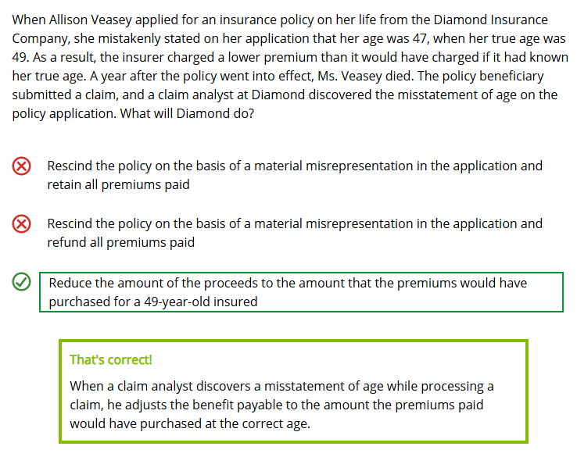

Note that if an insurer discovers a misstatement of age or sex while the insured is still alive, it will often offer the policyowner the option of adjusting the face amount or of maintaining the same face amount and adjusting the premiums payable for the policy.
Determining the Proper Payee
After figuring out the amount of policy proceeds, the claim analyst decides who is entitled to the proceeds. Sometimes claim analysts receive conflicting information about who is entitled to death benefits. At other times, they must decide how a claim should be paid.
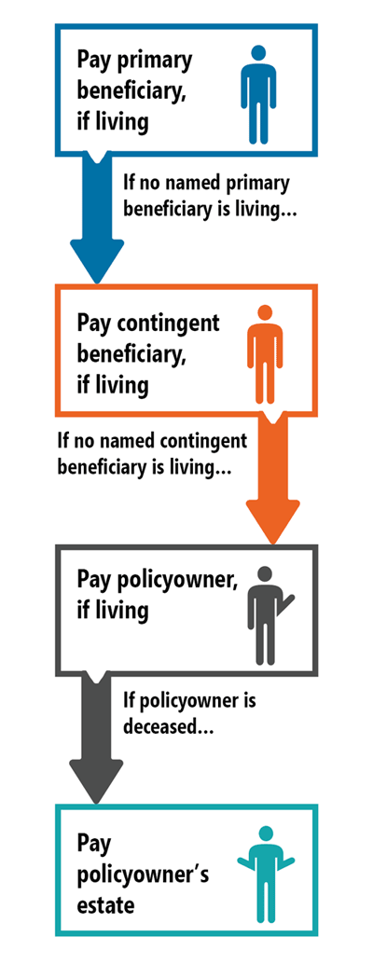
In most cases, the insurer pays the death benefits to the primary beneficiary or beneficiaries named by the policyowner. If no primary beneficiary is alive at the time of the insured's death, the insurer will pay the benefits to the contingent beneficiary, or second contingent beneficiary if the contingent beneficiary is deceased. If a contingent or second contingent beneficiary cannot be paid, the proceeds will be payable to the policyowner. If the policyowner is deceased, then the proceeds will be payable to the policyowner's estate.
The claim analyst will do whatever he can to ensure that he identifies the proper payee, but there are instances when the beneficiary designation is ambiguous or two payees seem to have rights to the proceeds. The insurer will encourage the parties involved to resolve the issue, but occasionally, when the parties cannot agree, the insurer will take legal action through a process known as interpleader. The insurer goes to court, tells the court that it can't determine the proper recipient of the proceeds through no fault of its own, and asks the court to determine who has rights to the proceeds. Interpleader eliminates the risk that the insurer may have to pay proceeds more than once.
Determining the Proper Payment Method
A beneficiary can receive policy proceeds in a lump sum or under one of several settlement options.

Let's see what you already know about settlement options. Identify each settlement option described below.

Policy proceeds and interest are paid in equal installments for a specified period of time.
- Life Income Option
- Retained Asset Account (RAA) Option
- Fixed-Period Option
- Interest Option
- Fixed-Amount Option
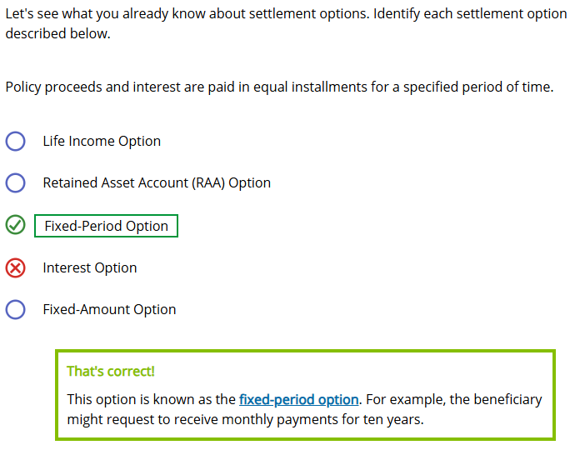

Policy proceeds and interest are paid in a series of equal payments for as long as the proceeds last.
- Life Income Option
- Retained Asset Account (RAA) Option
- Fixed-Period Option
- Interest Option
- Fixed-Amount Option
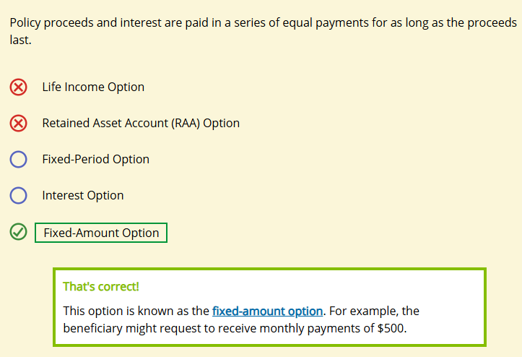
Policy proceeds and interest are paid in a series of payments over the payee's lifetime.
- Life Income Option
- Retained Asset Account (RAA) Option
- Fixed-Period Option
- Interest Option
- Fixed-Amount Option
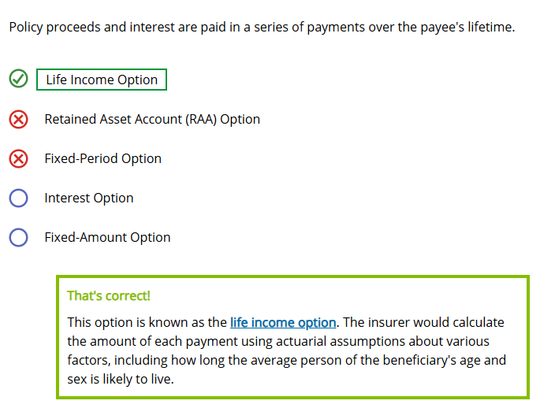
Policy proceeds are deposited into an interest-bearing checking account in the payee's name.
- Life Income Option
- Retained Asset Account (RAA) Option
- Fixed-Period Option
- Interest Option
- Fixed-Amount Option
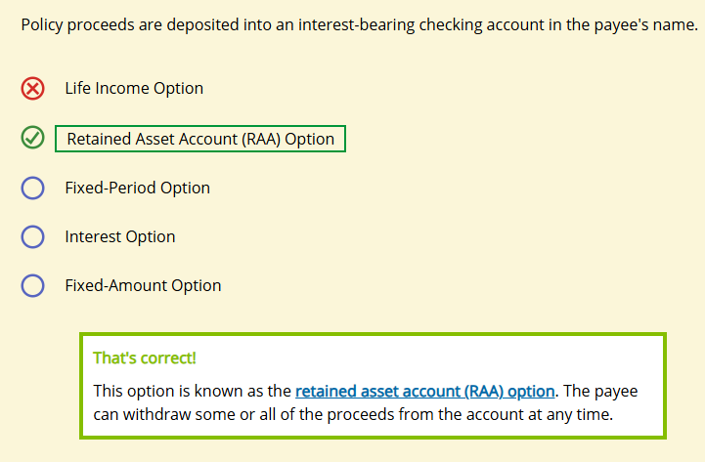
The insurer invests the policy proceeds and periodically pays interest on these proceeds to the payee.
- Life Income Option
- Retained Asset Account (RAA) Option
- Fixed-Period Option
- Interest Option
- Fixed-Amount Option
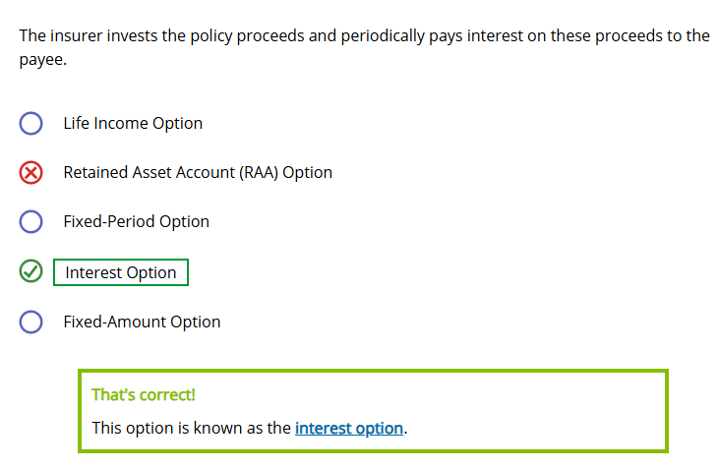

Annuity Death Benefit Process
Processing annuity death benefit claims is very similar to processing life insurance death benefit claims but differs in some ways. Use the right arrows below to look at the steps in this process.

1. Authenticating and Documenting the Claim
As with life insurance claims, annuity death benefit claims start with a claimant's statement and official death certificate.

2. Determining the Amount of the Death Benefit
The death benefit amount is usually the annuity's accumulated value on the day the insurer receives required documentation.

3. Addressing Applicable Tax Issues
Unlike life insurance death benefits, annuity death benefits typically result in taxable income to the beneficiary.
The insurer reports the total payment, the taxable portion of the payment, and any taxes withheld to the beneficiary and to tax authorities.

4. Paying the Death Benefit
The insurer pays the annuity death benefit as a lump sum or according to a settlement option chosen by the contract owner or beneficiary.


Yunel Mendoza was the insured under a $100,000 life insurance policy that included an accidental death benefit. After Mr. Mendoza died in an accident, a claim analyst approved the claim and determined the following amounts pertaining to the policy:
- $300 in premiums paid in advance
- A $3,000 outstanding policy loan
- $200 in accrued policy loan interest
- $5,000 paid up additional coverage
- $400 in declared but unpaid policy dividends
- $100,000 accidental death benefits

What are the total proceeds payable to the beneficiary?
- $201,700
- $202,500
- $205,700
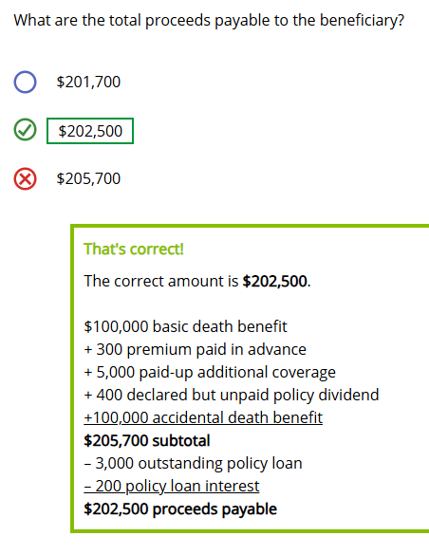
When Mickey Evans dies, his life insurance policy proceeds can't go to his named beneficiary, his wife Carla, because she is also dead. He named their adult son Alex as the contingent beneficiary, and his adult daughter Abigail as the second contingent beneficiary. Both children are still alive. In this case, who will receive the proceeds of his policy?
- Alex
- Abigail
- Alex and Abigail will each receive half of the proceeds

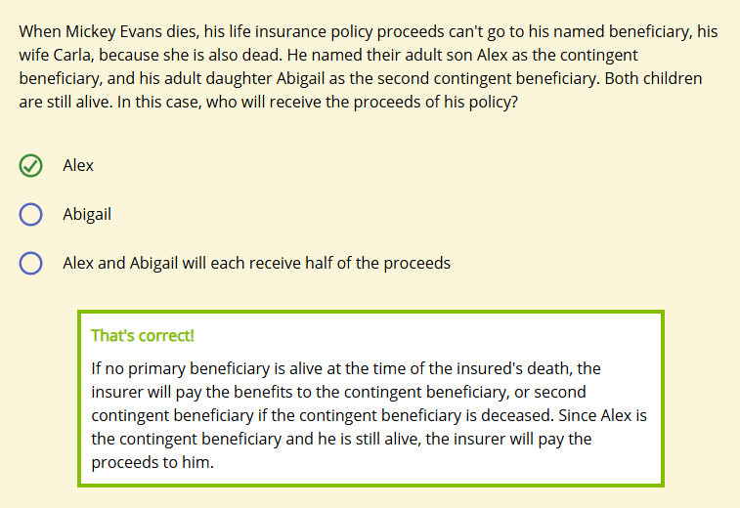

Claim Investigations and Claim Fraud
Learning Objective
Identify the factors that are likely to trigger a claim investigation, and describe different types of claim fraud and measures insurers can take to prevent them.
Now that you've learned about the claim process, let's discuss claim investigations. What if a claim analyst can't determine Forthright's liability because
- The claimant's statement and proof of loss document don't provide enough information or
- The correct payee isn't apparent…or maybe…
- Something just seems wrong
Any of these situations could trigger an investigation. Let's find out why.
Claim Investigations
If a claim analyst suspects material misrepresentation or fraud, the claim analyst launches a claim investigation, which is the process of obtaining the additional information necessary to make an appropriate claim decision. Although most claim investigations involve short, simple searches such as checking a medical record, a few can be quite extensive. For example, in more complicated cases, a claim analyst might call upon the special investigative unit (SIU), which is composed of representatives of the claim, legal, and internal audit departments, as well as independent investigators.
Sources of additional information for a claim investigation can include:
- Medical records
- Motor vehicle records
- Criminal court records
- Autopsy Reports
- Investigative consumer reports
- Any other source that might help

Some investigations are quick and simple. Others are extensive. Select all factors that might make the claim investigation extensive.
- Death is unusual given the insured's age
- Mysterious death
- Death occurred during suicide exclusion period or contestable period
- Policy has an exclusion rider
- Death is from natural causes
- Policy has a relatively high face amount
- Death happened abroad
When investigating claims, Forthright must
- Follow all privacy laws
- Obtain information by only lawful, reasonable, and ethical means
- Protect the confidentiality of information
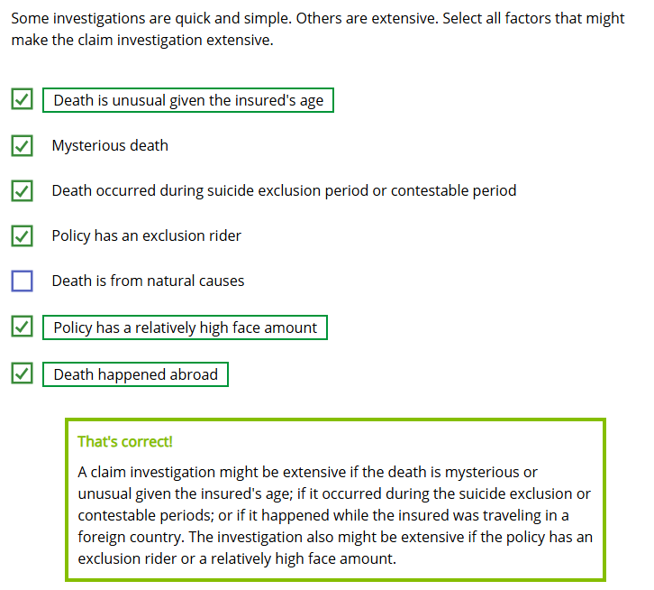
In many jurisdictions, conducting an investigation under a false pretext is prohibited.
In addition to complying with legal requirements, insurers like Forthright must also carefully weigh the potential benefits from a claim investigation against the costs. The costs of a claim investigation—staff salaries and the costs related to independent investigators—can be quite expensive. Generally, the more complex the investigation, the higher the cost involved.
Claim Fraud

Only an insured or a beneficiary can commit claim fraud.
- True
- False
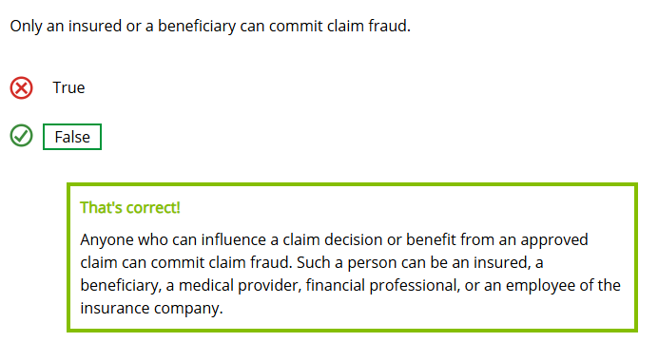
There are also numerous types of fraud for insurers to address.
Examples of Claim Fraud
- A man purchases life insurance on several homeless men, names himself as beneficiary, and then receives the policy proceeds after the insureds die.
- A claim analyst issues claim checks for the death benefits on life policies covering two nonexistent children. She invents police reports, doctors' reports, and even autopsy reports supporting the claims.
- A life insurance applicant pays a healthier person to take his medical examination so the applicant will be accepted by the insurer.
- A claim analyst approves a claim for life insurance benefits on a friend's mother, even though he knows the mother is still alive.
- A beneficiary claims that the insured died as a result of an accident in an attempt to receive the policy's accidental death benefit, even though the insured died of natural causes.
Preventing Claim Fraud
Some jurisdictions require insurers to take certain measures to prevent, detect, investigate, and prosecute claim fraud, and some states require insurers to form SIUs to investigate suspected cases of fraud. Claim analysts and SIU staff members receive training in detecting and investigating insurance claim fraud and in applying the provisions of unfair claim practices statutes. In addition, many state insurance departments have established their own fraud investigation units. Insurers also establish continuous education programs so employees can maintain awareness of existing and new fraudulent activities to minimize their impact on insurance operations.

Many insurers use data analytics to help them detect claim fraud. By analyzing the large amount of data they own relating to past claims, insurers can identify situations that indicate a heightened risk of fraud. For example, an insurer might discover that claimants who act in a certain way are more likely to be committing claim fraud. Such insights can help insurers identify which claims to investigate further. Insurers can also deploy software that automatically flags cases that exhibit any warning signs of claim fraud that the insurer has previously identified. As in many other areas, computers can generally perform this kind of task more accurately and consistently than humans.
Another way insurers can prevent claim fraud is through cross-departmental collaboration. Here, an expert explains how the claims and underwriting departments collaborate to prevent claim fraud.

Although verifying proof of loss is routine in most cases, a claim analyst would typically conduct further investigation in some situations. Identify whether the analyst would investigate further in each situation described below.

The insured was the only one aboard a boat that sank in calm waters 100 feet from shore, and the insured's body was not recovered.
- Investigate further
- Approve the claim
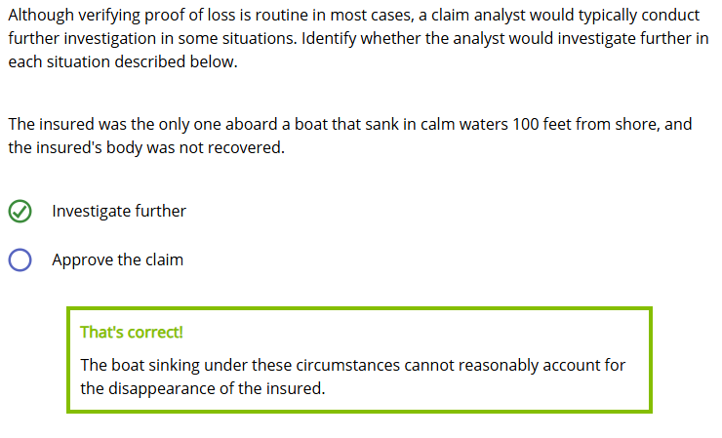
The insured disappeared under unverifiable circumstances but the claimant submitted a court order stating that the insured is presumed dead.

- Investigate further
- Approve the claim
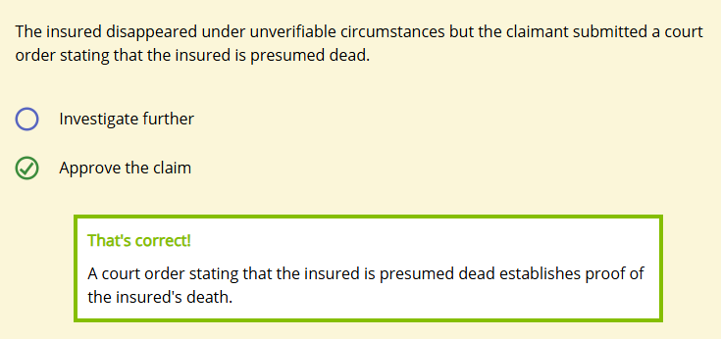
The insured died outside of the country in which the policy was issued.
- Investigate further
- Approve the claim
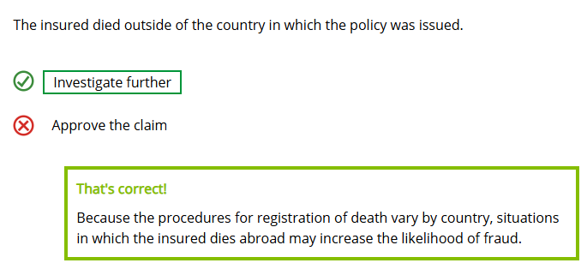
The insured died by suicide after the policy's suicide exclusion period expired.
- Investigate further
- Approve the claim
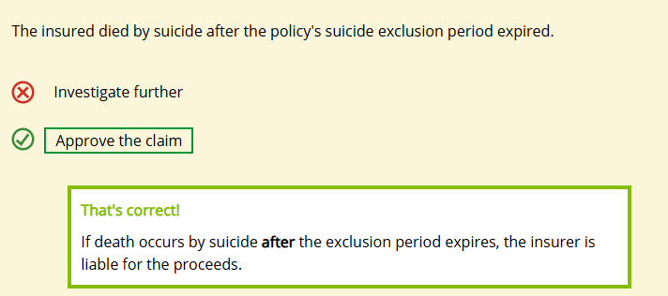
Use the following information to answer the questions below.

Fred Kingsley, a claim analyst, received a claim for the proceeds of a $500,000 life insurance policy. Although the claim included a claimant's statement and death certificate as proof of loss, Mr. Kingsley suspected claim fraud and initiated a claim investigation.
In this situation, claim fraud could have been committed by (choose all that apply)
- The policy beneficiary
- ☐ The medical provider who signed the death certificate
- ☐ The financial professional who sold the policy

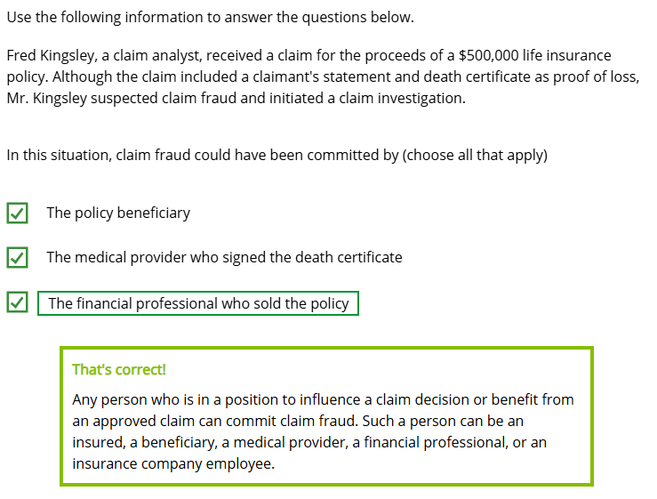
Mr. Kingsley from our previous question can protect the privacy of the insurer, the policy beneficiary, and other people involved in the claim investigation by concealing the actual purpose of the investigation from people he speaks to as part of the investigation.
- True
- False
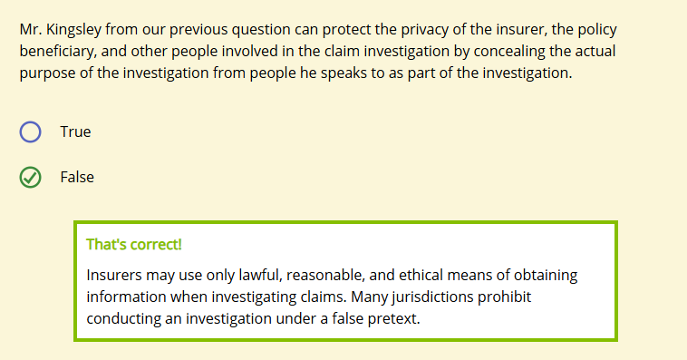

Unfair Claim Practices
Learning Objective
Describe the Model Unfair Claims Settlement Practices Act and give examples of unfair claim practices that would result in a violation of this act.
- 
Failing to promptly acknowledge receipt of claim-related communications
- Indicating the coverage under which each payment is being made
- Insisting on a reasonable claim investigation before affirming or denying a claim
- Attempting to settle claims based on an application that was materially altered without the policyowners' knowledge
- Requiring a proof of loss form as well as subsequent verification that duplicates the original proof of loss
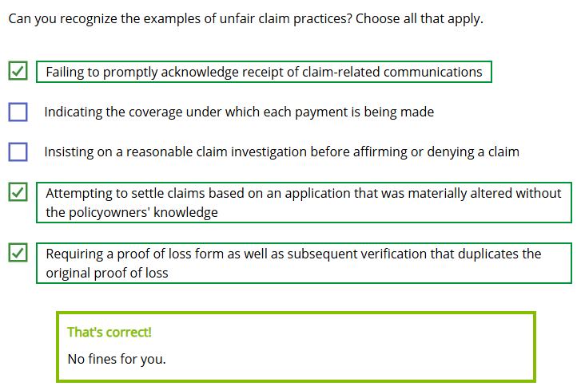
Can you recognize the examples of unfair claim practices? Choose all that apply.
Examples of Unfair Claim Practices
Most states have laws based on the Model Unfair Claims Settlement Practices Act from the National Association of Insurance Commissioners (NAIC).
These laws describe specific actions that are considered unfair claim practices if done (1) in conscious disregard of the law or (2) so frequently as to indicate a general business practice.
Prohibited practices include
- Failing to promptly acknowledge receipt of claim-related communications
- Failing to affirm or deny coverage of claims within a reasonable time after the claim investigation is completed
- Attempting to settle claims based on an application that was materially altered without the policyowners' knowledge
- Requiring a proof of loss form as well as subsequent verification that duplicates the original proof of loss
- Compelling claimants to initiate lawsuits to recover death benefits by offering substantially less than the amounts due
- Knowingly misrepresenting to claimants and insureds relevant facts or policy provisions relating to coverages at issue
- Refusing to pay claims without conducting a reasonable investigation
- Failing to provide forms necessary to present claims within fifteen (15) calendar days of a request with reasonable explanations regarding their use
Making Ethical Claim Decisions
Click or touch the right arrows below for an example of ethical decision making.

"Hey, John. I need to improve our department's results. I'll just keep this claimant's statement in a drawer. If another claim comes in on the same case, I'll create a file and pass it to you. Then I'll need you to deny the claim. If we get a third claimant's statement, then we'll open an investigation. No need to mention this to anyone else."
It seems that John has an ethical dilemma. Deep down John knows that his manager's order isn't the right thing to do. Potential consequences that could arise from this unethical action include
- Regulatory fines
- Financial professionals placing business elsewhere
- Disciplinary action for the employee
- Legal action against the company
- Rating downgrade

Select the interaction between a claim department and a customer that would be considered an unfair claim settlement practice under the (NAIC) Model Unfair Claims Settlement Practices Act.

- Claim analyst Marie Kensington hired an outside investigator to verify information related to a claim.
- Claim analyst Garth Giske frequently authorizes claim settlements that are substantially less than the actual amount due.
- After reviewing a claim for accidental death benefits, claim analyst Maxine Harmon determined that the claimant had misinterpreted the policy's accidental death benefit provision and denied the claim.
- Trent Jeffers, an analyst trainee, unknowingly failed to complete his first claim investigation within the required amount of time after receiving proof of loss.

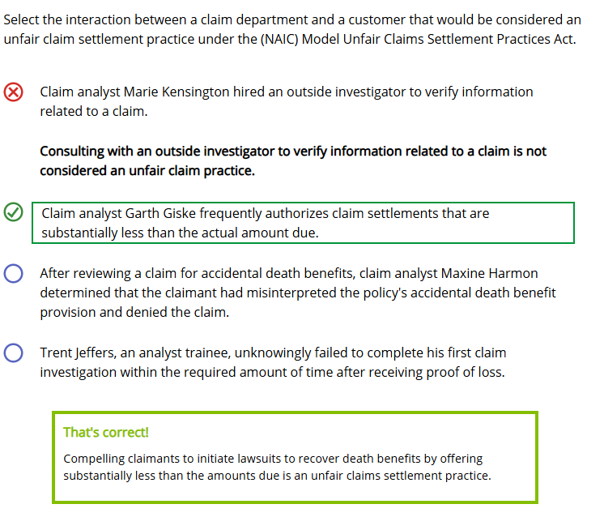

Claim Processing Efficiency
Learning Objective
Explain various ways that insurers improve and evaluate claim processing efficiency.
An insurer expects its claim staff to process claims quickly and thoroughly. Usually, insurers set goals for a certain number of claims to be processed within a certain time frame. However, meeting that time frame cannot be done at the expense of accuracy or quality.

The Role of Automation

Companies can use technology to automate existing tasks. Computers can perform many tasks quickly, cheaply, and with consistent quality. The best candidates are generally highly repetitive tasks with well-defined rules, such as routine, uncomplicated life insurance claims.
When computers automatically pay claims that meet certain requirements and are below a specified dollar amount, claim department staff are freed up to concentrate on investigating less routine claims for fraud or unintentional mistakes.
Claim Audits
Insurers conduct internal audits of approved and denied claims, and are also subject to external audits of claim practices.


"One way we know the claim department is running efficiently is when reinsurers audit its procedures, and its quantitative and qualitative measurements are right on target, particularly when it comes to balancing accuracy with speed."
As this graphic illustrates, an insurer can face consequences if it pays a claim too slowly or too quickly.
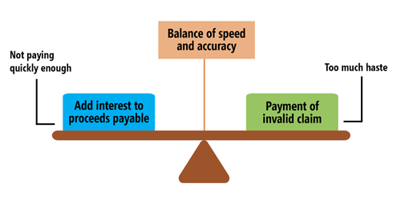
Companies can also evaluate claim processing efficiency by reviewing market conduct exam results. For example, imagine that our fictional company, Forthright Financial, underwent a market conduct exam. Here are some factors that states generally verify during a market conduct exam.

Forthright's Claim Practice Market Conduct Exam Results
The company:
- Adheres to policies and procedures
- Processes claims according to policy terms
- Investigates and settles claims on time
- Adequately and accurately documents files
- Accurately calculates claim payments
- Pays claims to the correct payees
- Doesn't violate the Model Unfair Claims Settlement Practices Act

One benefit of automated claims processing is that companies can rely on computers to process complex claims.
- True
- False
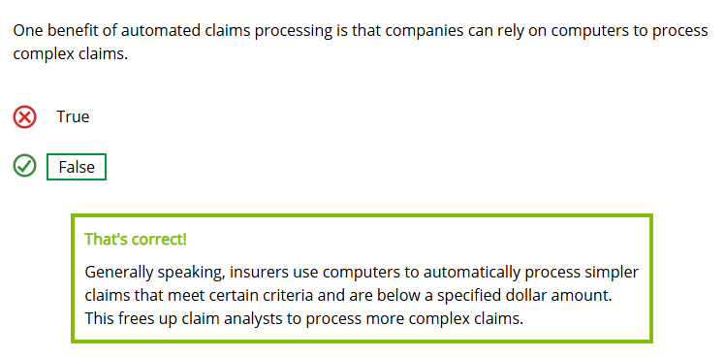
Market conduct exams evaluate how well an insurer's claim department handles various aspects of claim processing, including (choose all that apply)
- Processing claims according to policy terms
- Investigating and settling claims on time
- Accurately calculating claim payments
- Paying claims to the correct payee
- Ensuring that staff comply with the Model Unfair Claims Settlement Practices Act
